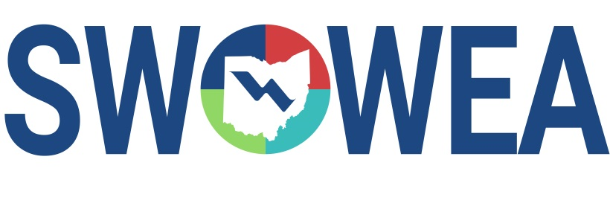
Presents the
SWOWEA August Nearly Free Seminar
August 12, 2020
hosted by
SWOWEA PLANT OPERATIONS COMMITTEE
PRESENTATIONS
9:00 – 10:00 AM Chemical Applications to Control Struvite & Vivianite
10:00 – 10:30 AM OEPA Sewage Sludge Update

CONTACT HOURS
1.5 Contact Hours Available.
Pre-Register Online by 08/07/2020 at www.ohiowea.org
Registrations will only be accepted online, the digital format will not allow for same day registration. Class size may be limited, pre-registration guarantees your seat. Also you will need to register with Go To Meeting as well as OWEA, a link will be sent after your registration has been processed.
Questions? Please contact Bryan McNutt at (937) 478-7723 or bryanm@cityofmiddletown.org

